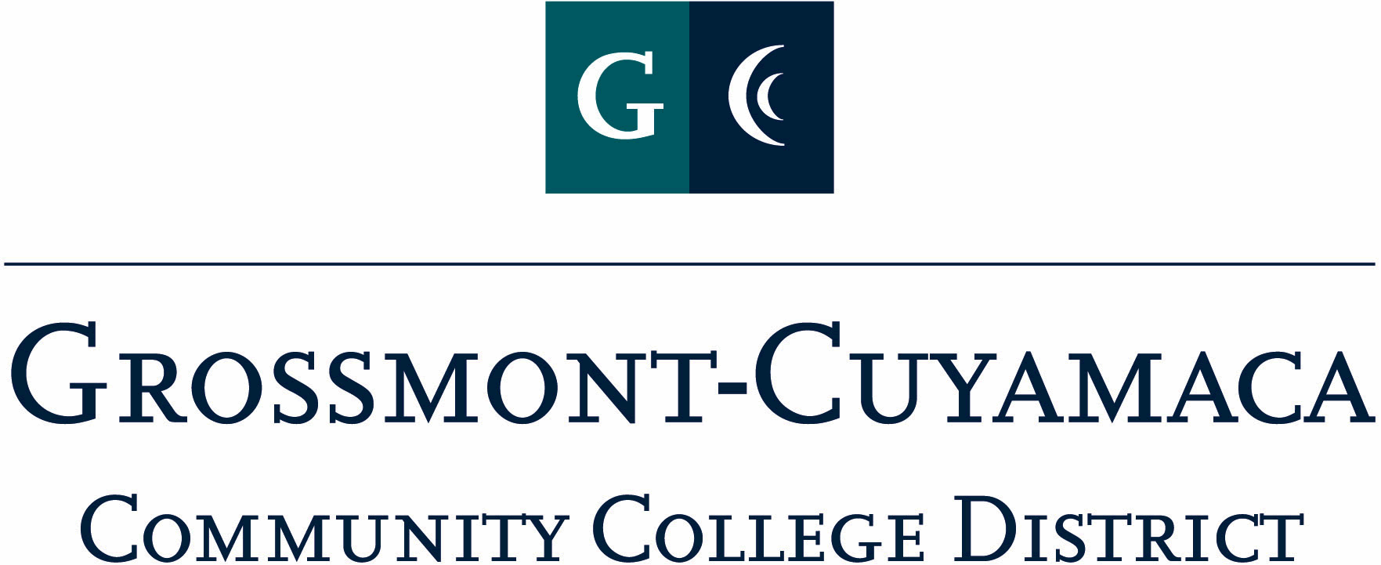
CLASSIFIED SENATE
EXECUTIVE BOARD MEETING
March 1, 2011– Meeting Minutes

Members Present: Debi Miller, Lynne Davidson, Wendy Corbin, Yvette Macy, Scott Howell, Maria Briney, JacQ Osborne, Angela Johnson, Pat Murray, Karen Ostegard, Karen McCoy, Jean Wallace, Joe Balistreri, Maggie Gonzales, Patricia Bailey, Avelina Mitchell, Rocky Rose
Members Absent: Monica Farris
Members Excused: Paula Tillery

1. Welcome and Call to Order

The meeting was called to order at 12:05p.

2. Approval of Minutes from

The minutes from February 1, 2011 meeting were approved. M/S/A Rose/Macy.

3. Continuing Business: CSAD Committee Reports
- Food – Chairs Avelina Mitchell and Monica Farris. Avelina Mitchell reported that the food committee had met with Sodexo who declined to take our event. Since they did not offer any discounts this year, their price was out of our budget, and did not try to accommodate. We are checking other vendors to see if they would be able to do it within our budget. She explained what food was being offered at Breakfast & Lunch to include a buffet style to go along with the Las Vegas theme.
- Facilities – Chairs Scott Howell and Maria Briney. The facilities committee met with Patty Branton, Facilities Clerk at CC and Dave Dehaven, Custodian to set up the organization of the 3 conference rooms to include: belly tables, lounge set-up and dining tables. The lunch-time band will be set up outside on the balcony outside conference room I 209. This change was made in consideration to avoid the labor intense canopy set ups out in the quad area. Scott and Maria will coordinate with Jon Langteau, Electrical Maintenance, and Cyndy Bourget, Instructional Media Services Coordinator to coordinate the set up for power, mics, audio equipment, laptop for presenter, etc. President Miller reported she is talking to student representatives for additional music.
- Workshop & Entertainment – Chairs Wendy Corbin and Maggie Gonzales. Wendy reported that the e-mail went out district wide for those interested in conducting a workshop. She is working on contacting some of our past presenters to see if they would be interested. She is working with Maria Briney and Pat Murray to handle the fiscal documentation. She went through some of the workshops she currently has confirmed and several new ones such as CalPERS 403B, finding things on the district and library website, a nature walk, and a funny potato chip presentation. She will e-mail the Water Conservation Garden about giving a tour that day. President Miller reported invitations were delivered to Governing Board members, 3-site administrators, Academic Senate presidents, and college student leaders.
- Public Relations – Chairs Angela Johnson and Jean Wallace. Angela Johnson reported that she is the process of developing the program brochure. The President will send the evaluation template to them.
- Raffle & Donations – Chair Yvette Macy. Yvette Macy reported that the raffle and donations are going well and she will be sending out reminder e-mails. Please send her any ideas you may have of who else she could solicit for donations. She will forward to the group her top 3 ideas for give-away gifts. The President will send out an e-mail for a majority vote. Yvette Macy will also send out her ideas for presenter gifts.

Lynne Davidson suggested that we have an award for most energetic, most themed, Elvis w/sideburns. The President would like to bring to the Annual Organization Meeting on 3/24 for further discussion and decision.

- Fiscal Coordination – Chair Pat Murray. She reported that she is working with Wendy Corbin on the list of those presenters that need to submit district paperwork so payment is received by 4/15.

Debi Miller reported that she is currently working on securing the lunch-time band (3 piece) and the morning musician.

Screening Committee (Internal Process): M/S/A Rose/Murray. Motion passed.

4. Communication

VP Reports

District: Wendy Corbin reported that she did not have a chance to meet with Sue Rearic about classified senate concerns. She is continuing to work with Ms. Rearic on internal processes for Classified Senate. She also included:
- District Services is conducting a workshop on the processes for district input
- Planning & Budget has expanded their membership to include 4 classified
- Benefits Committee will be meeting on 3/2 – anyone is free to attend.

Wendy Corbin updated the group on her recent attendance at District Executive Council:
- Change in Governing Board Process for elections
- Business Office indicates that payroll bottom line is up
- Water Conservation Garden donated a truck
- Academic Senates are discussing pre-requisite enforcement and unified across district

Grossmont: Pat Murray reported that she had a conversation with Dr. Cooke about having the classified voice as part of department staffing planning. The Task Force took to Chancellor’s Cabinet and their approach was to take it to a broader approach to planning and that each site director needs to bring to their VPs or budget & planning council to talk about how we can get classified involved with the planning process on all levels. Even though there may be some staff who are not interested, the Classified Senate leadership needs to be purposeful and possess the intent of getting them involved. She brought this question to the Planning & Resource Council and those constituency leaders responded by indicating they would take the Classified Senate concerns back to the Chairs & Coordinators and Academic Senate and to find a way to include classified in program review and annual planning activities.

Cuyamaca: Maggie Gonzales reported that in her area she is having trouble getting coverage to attend meetings, but is working on it. She attended the IPC meeting and the College Accreditation Steering Committee meeting which now includes classified as chairs. They are starting to work on the climate survey. The other classified on the Steering Committee include: Rocky Rose, Connie Sterling, and Sara Grasmick.

The group then had an impromptu conversation about: budget and summer schedule.

Treasurer Report: Tabled
President’s Report:

Annual Organization Meeting: Debi Miller reminded the group of the upcoming Annual Organization Meeting.

CSAD Keynote: The keynote speaker has been secured for Classified Staff Appreciation Day.

CLI Scholarship: Debi Miller announced that Karen McCoy declined the scholarship and that it would then go to Joe Balistreri – next in line. Congratulations to Joe!

5. Fundraising Activities:

See’s Candy: Lynne Davidson is working on the flyer and the ordering window will be 3/14-4/11 to make a delivery by 4/14.

6. Governance:

Classified Professional Development Committee: The committee will be meeting to go over the survey results and report back to the group at the next meeting.

7. New Business: Nothing brought forward.

The meeting adjourned at 1:01p.

